PRE MODEL ACTIVITY

1)CLASS CAR USING PRIVATE ?

CODE:

#include <iostream>

using namespace std;

class Car {

private:

string model,make;

int year;

public:

void getdata(){

cout<<"enter make:"<<endl;

cin>>make;

cout<<"enter model:"<<endl;

cin>>model;

cout<<"enter year:"<<endl;

cin>>year;

}

void display(){

cout<<make<<endl;

cout<<model<<endl;

cout<<year<<endl;

}

};

int main(){

Car o;

o.getdata();

o.display();

return 0;

}

OUTPUT:

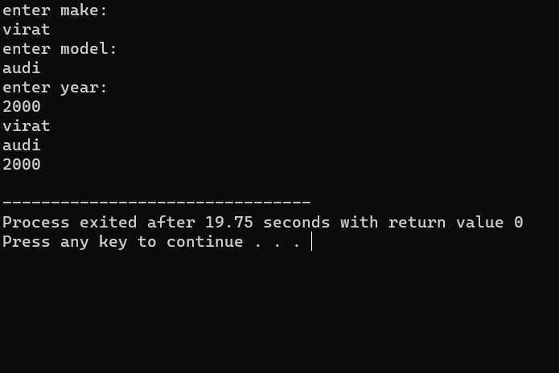

2)CLASS PROGRAMMING ?

CODE:

#include<iostream>

using namespace std;

class programming

{

public:

programming (){

cout<<"I LIKE PROGRAMMING"<<endl;

}

programming (string s){

cout<<"I LIKE STRING";

}

};

int main(){

programming obj,obj1("madhan");

}

OUTPUT:

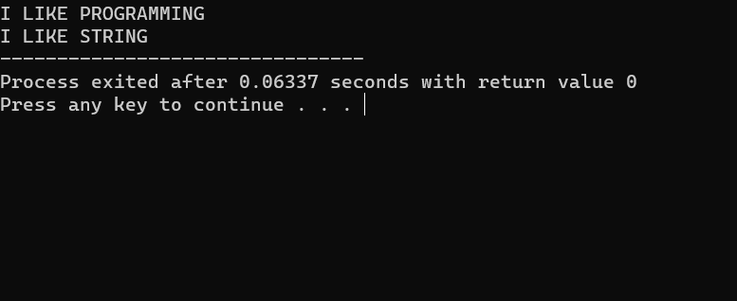

3)RIGHT HALF PATTERN ?

CODE:

#include<iostream>

using namespace std;

int main()

{

int a;

cout<<"enter range:"<<endl;

cin>>a;

for(int i=0;i<a;i++){

for(int j=0;j<=i;j++){

cout<<j+1;

}

cout<<endl;

}

return 0;

}

OUTPUT:

